1. **03/10/2024**: Meet & Greet: Quick go-around to briefly introduce ourselves
   1. Name
   2. Where were you born
   3. 3 words that a close friend might use to describe you
2. St Theodora Adult Ministry 3nd meeting for 2024
3. **Why this minis**try? As Fr Gabriel described – we come to Church to worship the Holy Trinity and have communion, but individually we are all working to put off the “old man”. We have questions…but collectively we have wisdom.
   1. We want to share that wisdom – Fathers, the “Saints”, and everyday saints…us!
   2. Have a focused study
   3. Cheer each other on as we run our races as if our lives depended on it – because they do!
4. **Ground rules**: We love and accept each other – we “listen”
5. **When does prayer begin?** Prayer begins the day when God is absent; when He is silent.
   1. **Please answer the following 3 questions**
   2. Were you able to read the 2nd chapter?
   3. Were you able to sit in stillness for at least 5 mins 1X-2X per day?
   4. Do you have any “quotes” or “saying” from the Saints or Fathers that you would like to share on this chapter?
6. **Questions for Chapter 2: Did you review the questions? We will cover in our discussion…**
   1. Are you able to sense the depth that you are “outside” of the kingdom of God?
   2. What is meant by increasing progression towards a deeper, richer, longing for the presence of God?
   3. Have you ever heard the saying: “You will never see a hearse pulling a U-Haul”. How do our possessions and wealth burden us, and keep us from the kingdom of God?
   4. What are the Beatitudes? Discuss the first Beatitude. Blessed are the Poor In Spirit
   5. Why does Jesus say to His disciples, “Assuredly, I say to you that it is hard for a rich man to enter the kingdom of heaven…” (Matthew 19:23)?
   6. How can our imagination entangle us?
   7. Discuss: “Find the door of your heart, you will discover it is the door of the kingdom of God
7. **“Beginning to Pray” by Metropolitan Anthony Bloom – Chapter Two: Knocking at the Door**
   1. **Quick recap from Chapter One**: Metropolitan Anthony Bloom realized the absence of God. He felt that there was a lack of a genuine relationship with the living God. He then realized through prayer that he could begin to sense the presence of God. This was a profound change in his Christian life. He is sharing ways to approach prayer so that we too may sense the absence, and therefore be able to change our lives in Christ as well – change behavior
   2. **Shifting from the absence of God to the presence of God is a process**…a journey. It does not happen spontaneously (without the grace of God)
   3. We may spend a great deal of our lives imagining that we are inside (the kingdom of God), behaving as though we were there already…and *never reaching that depth where the kingdom of God unfolds itself in all its beauty, its truth, its glory*.
      1. An example of a way to contemplate this: The colors that we do not see/perceive (see attachment). Our perception is limited in other ways as well – spiritually, in loving others, listening, being present
      2. We should think in terms of depth here…he says “an increasing progression from depth to depth, from height to height. Even if we already sense the presence of God, we must continually strive for something “richer and deeper”
      3. God has given us so much – intellectually, emotionally, our lives are so full that we may imagine that there can be nothing more than this, that we have found fulfilment and wholeness, that we have reached the end of our search…But we must learn that there is always more.
      4. And... We must rejoice that, poor as we are, we are so rich; yet we must long for the true riches of the Kingdom
         1. Being careful not to be satisfied or beguiled by what we already possess
   4. The first Beatitude is one of poverty: There are two aspects to this Beatitude
      1. Beatitude definition: See Attachment (Blessedness – ideal Christian life)
      2. Notes: Only if we live according to this Beatitude can we enter into the kingdom of God.
      3. First realize that all of our possessions are a gift from God (Recall the hearse pulling the U-Haul – all is temporary)
      4. Aspect One
         1. We possess nothing we can keep (yet we are in possession of…)
         2. The discovery that I am nothing and that “I” have nothing (I belong to God – He willed me into existence and everything that I have in my possession is a gift from God to make something of)
         3. We do not possess life in such a way that it is impossible for anyone to take it away from us, and all that we are and all that we possess is ephemeral (transitory/fleeting) in this way. He described how delicate our bodies really are.
      5. Aspect Two:
         1. We are rich, and everything which we possess is a gift and a sign of the love of God and the love of men, it is a continuous gift of divine love; as long as we possess nothing, love divine is manifested continually and fully. But everything we take into our own hands to “possess” is taken out of the realm of love.
         2. It becomes ours, but love is lost – God always gives US free will – we cannot force anything with God – if we force with anything else it can become evil
         3. Only those who give everything away who become aware of true, total, final, irremediable, spiritual poverty, and who possess the love of God expressed in all His gifts. (Meaning no ties or greed)
            1. The moment we try to become rich by keeping something safely in our hands, we are the losers, because as long as we have nothing in our hands, we can take, leave, do whatever we want…(inner peace? The more you have the more you want, etc…)
            2. He says: This is the kingdom, the sense that we are free from possession, and this freedom establishes us in the relationship where everything is love—human love and love divine (where we actually become human – in the likeness of Jesus Christ)
         4. The Parable of the Talents: God gives us all of our gifts; each according to our abilities.
            1. The amount shows the goodness that God has bestowed onto each man. God does not show partiality in the ultimate reward, for all are invited to share the same joy. “The wind blows where it wishes, and you hear the sound of it, but cannot tell where it comes from and where it goes. So is everyone who is born of the Spirit.” (John 3:8) - according to the Orthodox Bible: “the Spirit moves where He wills and cannot be contained by human ideas or agendas”.
            2. Diving deeper – the Master goes away and returns after a long time, and each servant is called to account for what was given. How much good was done with what was offered by God? The servants return all to the Master, but they are given more within his realm – more ability to do greater things…enter into joy with your master.) (Matthew 25:14-29). Note that they return ALL…to God
         5. 14“The Parable of the Rich Fool – Tears down his barns to build bigger barns to store-up his harvest. “Soul, you have may goods laid up for many years; take your ease, eat, drink, and be merry.” “God says to him, “Fool! This night your soul will be required of you; then whose will those things be which you have provided?” “So is he who lays up treasure for himself, and is not rich toward God.” (Luke 12:15-21)
            1. Beware of Covetousness (one’s life does not consist in the abundance of the things he possesses, storing up possessions – hoarding and selfishness).
            2. If you focus on your riches, your heart will be close as well – small and hard like a stone

But…the moment that you reach rock bottom, the moment you are aware of your utter dispossession of all things, then you are on the fringe of the kingdom of God, you are nearly aware that God is love and that He is Upholding you by His love. This is the point that you can say two things simultaneously:

You can pray out of your utter misery, dereliction and poverty

You can rejoice that you are so rich with the love of God

Until you come to this point though, as long as you imagine you are rich, there is nothing to thank God for, and you cannot be aware of being loved.

* + - * 1. Too often our ‘thanks giving” offered is too much a general thanks giving, and the kind of repentance we bring to God; is too much a general repentance (be specific – be real – don’t gloss over (God will know)
        2. Story of the cucumber: after giving true thanks to God, they ate it as a sacred food…why gluttony dulls our realization and puts distance between us and God
      1. We cannot live a life of prayer, we cannot go ahead Godward, unless we are free from possession in order to have two hands to offer and a heart absolutely open—not like a purse that we keep close in our possession and make sure constantly that it is closed. But instead like a purse that is open and empty—and an intelligence completely open to the unknown and the unexpected. It is at this point that we can speak of being outside the Kingdom and yet be so rich inside and yet also so free.
      2. Fasting: When we fast, not only the fasting that affects the stomach, but that attitude of sobriety which allows you, or compels you, never to get enslaved by anything.
      3. Sin begins in the imagination: ‘Orthodox brother in the 9th century said that sins of the flesh are the sins which the spirit commits against the flesh. It is not the flesh that is responsible, and I think in that sense we must learn to control our imagination.’
         1. Once our imagination is entangled and imprisoned in things, then we are glued to things. We must fast from letting our imaginations run wild.

Why are monks always busy? Why are Christians encouraged to not be idle/slothful? Many examples in the Bible – search for slothful!

* + - * 1. Every one of our natural propensities has got a counterpart which is marked by evil (hunger/greed, rest/laying around all day), attachment/love) and which is one of the ways in which we get enslaved.
        2. To begin with, say “NO”. If you don’t say “NO” from the start, you are in for a fight. Then you must be ruthless about it, because reason and detachment are more precious than wheat you get as a slave in terms of enjoyment. So: Head off these thoughts of the imagination at the start – don’t give
        3. All evil begins with a thought. Frederica Matthews-Greene describes “There’s a part of our mind that’s like a little island, where you notice your thoughts as they come and go. There you can evaluate them, and decide whether to take them up or turn them away. …it’s the place where, when you have a stupid idea, it tells you, “That’s a stupid idea”.
  1. (Christopher) “If what I have said so far is true, we must ‘knock at a door’ p 44
     1. Certain problems become very acute
        1. Where do we knock? What is the purpose of ‘this prayer’?
        2. Where should I turn my gaze and my heart?
     2. Focus: Can be nothing less than God
        1. Imagination…Tradition warns us not to use our imagination in speaking with God.
           1. An imaginary God puts an idol between you and God
           2. Not God as ‘we’ imagine Him
        2. Collect all the knowledge of God which we possess in order to come into His presence
           1. Remember that all we know about God is our past, as it were, behind our back, and we are standing face to face with God in all His complexity, all His simplicity, so close, and yet so far
           2. Only if we can stand completely open before the unknown, can the unknown reveal itself, Himself, as He chooses to reveal Himself to us as we are today
           3. We must stand before God without trying to give Him a shape or to imprison Him in concepts and images…and we must knock at the door
     3. …Where and Towards What? (First: Inward, Second: The Words in Prayer and the direction in which to turn them.)
        1. **1st: Inward**
           1. The Gospel tells us that the kingdom of God is within us (Luke 17.21 Ecc 3.11) ; if we cannot find the kingdom of God within us, then we cannot meet God within…in the very depths of ourselves, our chances of meeting Him outside ourselves are very remote.
           2. Russian Astronaut: Gagarin, when he came back from space and made his remark that “he never saw God in Heaven”, one of our priests in Moscow remarked ‘If you have not seen Him on earth, you will never see Him in Heaven.’
           3. If “we” cannot find a contact with God under our own skin, as it were, in this very small world which I am, then the chances are very slight that even if I meet Him face to face, I will not recognize Him.
           4. St John Chrysostom said: “Find the door of your heart, you will discover it is the door of the kingdom of God.”
           5. “The heart itself is only a small vessel, yet dragons are there, and lions, there are poisonous beasts, and all the treasures of evil, there are rough and uneven roads, there are precipes; but there too is God and the angels, life is there, and the Kingdom, there too is light, and there the apostles and heavenly cities, and treasures of grace. All things lie within that little space.” – St Macarius of Egypt (see attachment)
           6. Not a journey of going inward into “myself”, but a journey through my own self, in order to emerge from the deepest level of self into the place where He is, the point at which God and I meet
        2. **2nd: The Words in Prayer and the Direction in Which to Turn Them**
           1. Words of Prayer are like an Arrow St John of the Ladder

Need bow and arm. Story of parks and rec

Aiming at the deepest point where God is to be found within us

Very often we are inattentive to prayer (our heart is not in it)

* + - * 1. Aim deeper and deeper

Choose the prayer (the words)

Carefully, authentically, own your prayer

Would you say this prayer to Him if you were truly standing face to face with the living God?

If you are uneasy, God may be uneasy (ask yourself – does this prayer seem right, fitting, truthful…)

So – find the words of prayer that are worthy of you and worthy of God. Metropolitan Anthony says that if you feel that the words are good enough…then God can accept them.

If, however, they are not good enough for you though, then leave God alone.

We must not try to find extraordinary words; words that we may feel are needed to be on the level of God. WE are Not on the level of God, we will always fall short. We can waste a great deal of time searching for the “right” words.

Story of Moses… p 48

* + - 1. Recap:
         1. Your prayer must be turned inwards, not towards a God of Heaven, nor towards a God far off, but towards God who is closer to you than you are aware

The first act of Prayer is to choose such words of prayer as are completely true to what you are, words which you are not ashamed of, which express you adequately and are worthy of you. Offer them to God with all the intelligence of which you are capable. Put all your heart into the act of worship. Recognition of God, an act of cherishing (true meaning of charity), which involves the heart and mind.

Ask yourself what words of prayer make sense for you to offer to God, whether they be your own or those of other people.

Ask yourself also how much they touch your heart – to what extent you are capable of concentrating your mind on them

*If you cannot be attentive, then why should God attend?*

If you learn to use a prayer you have chosen at moments when you can give all your attention to the divine presence and offer God this prayer, then gradually your awareness of God grows within you

* + - * 1. Such an extent of this awareness can grow so that whether you are with people, listening, speaking or whether you are alone working, this awareness is so strong that even if you are with people you will still be able to pray

Analogy from St Theophan the Recluse uses that is simple, crude (raw), “The awareness of God shall be with you as clearly as a toothache.”

We should develop an ache in our hearts (our core), a desperate longing for God, the feeling of ‘I am alone, where is He?’, at that moment when you have lost touch in prayer.

Loftier way of saying: Great joy has come upon us or a great pain or a great sorrow, we do not forget it in the course of the day. We listen to people, we do our work, we read, we do what we are supposed to do, and the pain of bereavement, the awareness of joy, of the exhilarating news is with us incessantly. This should also be the presence of God.

* + - * 1. One can pray at any time, doing anything

Condition ourselves to an attitude of ‘worshipful attention and of broken-heartedness’ first

Start to gain stability in our prayers – alert, attentive, focused, worshipful

Surrendering to God – start with moments when we can be present, have undivided attention, with our hearts and mind

The Little Fox:

The Little Prince:

**Questions for Chapter 3: Going Inward**

1. Metropolitan Anthony suggested that we direct prayer to ourselves, were you able to practice this approach?
2. In choosing a prayer (words of a prayer), what three (3) ways approaches can we use?
3. Metropolitan Anthony states that we are delusional if we expect to pray in which type of approach to choosing our words?
4. Why are the Psalms so important in our prayer life? Why are the prayers of the Saints important to learn, and why are they special?
5. What does Metropolitan Anthony mean by “A prayer makes sense only if it is lived? Have you tried to “live” a conviction from your prayer for any period of time?
6. What time limit is suggested for your prayer sessions? Why?
7. What does he mean by taking the words (of our prayers) for what they mean (ordinary speech), but we don’t connect them with other things we know?
8. What do we need to be aware of (within ourselves), when asking for God for help with our sins and temptations?
9. Is it important to have physical effort during prayer? Why?
10. What “monsters” do we meet as we go deeper into prayer? How do we deal with them?
11. Why is it important to “sit with yourself in the face of boredom”? Can you name a Saint that has a quote that applicable to this question?
12. What is meant by “throwing coins to someone without ever having seen him”? Why is that important? How might we “see” who we donate to, especially as we head into Lent?
13. How can despair help us to go deeper into our prayers and our relationship with God? How does Metropolitan Anthony suggest that we so first thing in the morning? Why is it important? How might we sabotage our prayer life?
14. What are your thoughts on “it does work, if you are simple enough to do it”? St Porphyrios tells us to ask God to give us the “strength to lead a simple spiritual life”…Why is the word “simple” profound in our Orthodox lives?



**The Beatitudes**

**In the Gospel writings, the beatitudes introduce the teachings of Jesus and are traditionally considered to contain the most concise summary of the spiritual life of man. In the Orthodox Divine Liturgy, the beatitudes are chanted when the Book of the Gospels is carried in solemn procession to the sanctuary to be proclaimed as the Word of God to the faithful. Thus it is the clear teaching of the Gospel and the Church that one enters into the mysteries of Christ and the Kingdom of God only by way of following the Lord’s teachings in the beatitudes.**

***And He opened His mouth and taught them, saying:***

***“Blessed are the poor in spirit, for theirs is the kingdom of heaven.***

***Blessed are those who mourn, for they shall be comforted.***

***Blessed are the meek, for they shall inherit the earth.***

***Blessed are those who hunger and thirst for righteousness, for they shall be satisfied.***

***Blessed are the merciful, for they shall obtain mercy.***

***Blessed are the pure in heart, for they shall see God.***

***Blessed are the peacemakers, for they shall be called sons of God.***

***Blessed are those who are persecuted for righteousness sake, for theirs is the kingdom of heaven.***

***Blessed are you when men revile you and persecute you and utter all kinds of evil against you falsely on My account.***

***Rejoice and be exceedingly glad, for your reward is great in heaven.”***

**(Mt 5.2–12; cf. Lk 6.20–26)**

**PERCEPTIONS:**

**How would our perception of the world change if we were capable of seeing colors that are currently invisible to us?**

**Color is a fundamental aspect of our perception and experience of the world. We use color to navigate our environment, identify objects, and even communicate with others. However, the range of colors we perceive is limited by the capabilities of our visual system. Humans have trichromatic vision, which means we are able to see a range of colors that can be described by three primary colors – red, green, and blue. But what if we were to expand our visual capabilities and see colors that are currently invisible to us? How would our perception of the world change?**

**To answer this question, we must first understand how humans perceive color. Our eyes contain specialized cells called cones, which are responsible for detecting light and color. There are three types of cones in our eyes, each sensitive to a different range of wavelengths of light. These cones are known as short-wavelength (S), medium-wavelength (M), and long-wavelength (L) cones, and they correspond to the colors blue, green, and red, respectively.**

**If we were to develop a new type of cone that was sensitive to a different range of wavelengths, we would be able to see colors that are currently invisible to us. For example, if we were able to detect ultraviolet light, we would be able to see colors that are currently only visible to certain animals, such as bees and butterflies. This would allow us to perceive a whole new range of colors, adding depth and complexity to our visual experience.**

**The impact of being able to see new colors would be profound. For one, it would change our perception of familiar objects and environments. A flower, for example, would no longer be just red or yellow, but could have additional hues and patterns that were previously invisible to us. This would give us a deeper appreciation for the complexity and beauty of the natural world.**

**Additionally, our ability to communicate and express ourselves through color would be greatly enhanced. Imagine being able to see and understand the full spectrum of colors used in art, fashion, and design. Our ability to convey emotions and convey messages through color would be expanded, resulting in more nuanced and richer forms of expression.**

**From a scientific perspective, being able to see new colors could revolutionize our understanding of the physical world. It could reveal hidden patterns and phenomena that were previously unseen. For example, certain chemical reactions may emit light in the ultraviolet range, and we would be able to witness these reactions in real-time, opening up new possibilities for research and discovery.**

**Of course, there are also potential challenges that come with seeing new colors. Our current visual system is finely tuned to process the colors we can see, and adding new colors could potentially overwhelm our senses. It would take time for our brain to adapt to these new visual inputs and integrate them into our perception of the world.**

**In conclusion, if we were able to see colors that are currently invisible to us, our perception of the world would be fundamentally changed. It would add richness and complexity to our visual experience, enhance our ability to communicate and express ourselves, and potentially revolutionize our understanding of the physical world. While there would undoubtedly be challenges to overcome, the idea of expanding our visual capabilities and exploring new colors is an exciting prospect that holds great potential for both scientific and personal exploration. (**[The Invisible Spectrum: Exploring The Colors Beyond Our Visual Range | MedShun](https://medshun.com/article/what-colors-can-we-not-see))

**The Talents**

**14“For the kingdom of heaven is like a man traveling to a far country, who called his own servants and delivered his goods to them. 15And to one he gave five talents, to another two, and to another one, to each according to his own ability; and immediately he went on a journey. 16Then he who had received the five talents went and traded with them, and made another five talents. 17And likewise he who had received two gained two more also. 18But he who had received one went and dug in the ground, and hid his lord’s money. 19After a long time the lord of those servants came and settled accounts with them.**

**20“So he who had received five talents came and brought five other talents, saying, ‘Lord, you delivered to me five talents; look, I have gained five more talents besides them.’ 21His lord said to him, ‘Well done, good and faithful servant; you were faithful over a few things, I will make you ruler over many things. Enter into the joy of your lord.’ 22He also who had received two talents came and said, ‘Lord, you delivered to me two talents; look, I have gained two more talents besides them.’ 23His lord said to him, ‘Well done, good and faithful servant; you have been faithful over a few things, I will make you ruler over many things. Enter into the joy of your lord.’**

**24“Then he who had received the one talent came and said, ‘Lord, I knew you to be a hard man, reaping where you have not sown, and gathering where you have not scattered seed. 25And I was afraid, and went and hid your talent in the ground. Look, there you have what is yours.’**

**26“But his lord answered and said to him, ‘You wicked and lazy servant, you knew that I reap where I have not sown, and gather where I have not scattered seed. 27So you ought to have deposited my money with the bankers, and at my coming I would have received back my own with interest. 28So take the talent from him, and give it to him who has ten talents.**

**29‘For to everyone who has, more will be given, and he will have abundance; but from him who does not have, even what he has will be taken away. 30And cast the unprofitable servant into the outer darkness. There will be weeping and gnashing of teeth.’ (Matthew 25:14-29)**

**Covetousness**

**15And He said to them, “Take heed and beware of [c]covetousness, for one’s life does not consist in the abundance of the things he possesses.” 16Then He spoke a parable to them, saying: “The ground of a certain rich man yielded plentifully. 17And he thought within himself, saying, ‘What shall I do, since I have no room to store my crops?’ 18So he said, ‘I will do this: I will pull down my barns and build greater, and there I will store all my crops and my goods. 19And I will say to my soul, “Soul, you have** **many goods laid up for many years; take your ease; eat, drink, and be merry.” ’ 20But God said to him, ‘Fool! This night your soul will be required of you; then whose will those things be which you have provided?’21“So is he who lays up treasure for himself, and is not rich toward God.” (Luke 12:15-21)**

**ST. MACARIUS THE GREAT. HOMILY: The Heart is Christ’s Palace**

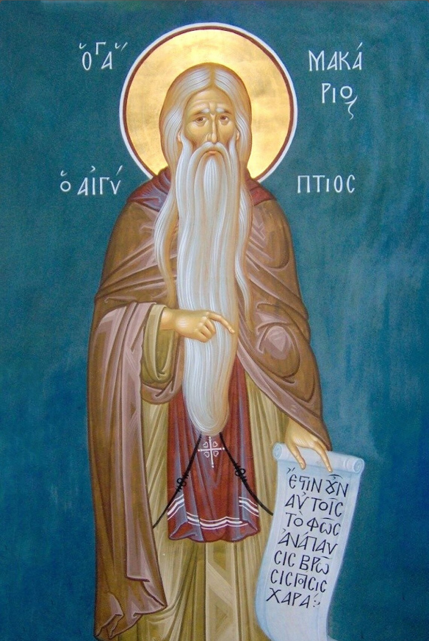

In his Homilies St. Macarius develops the idea of the Heart as the center of life when he writes:

The heart governs and reigns over the whole bodily organism; and when grace possesses the ranges of the heart, it rules over all the members and the thoughts. For there, in the heart, is the mind, and all the thoughts of the soul and its expectations; and in this way grace penetrates also to all the members of the body… Within the heart are unfathomable depths. There are reception rooms and bedchambers in it, doors and porches, and many offices and passages. In it is the workshop of righteousness and of wickedness. In it is death; in it is life… The heart is Christ’s palace; there Christ the King comes to take His rest, with the angels and the sprits of the saints, and He dwells there, walking within it and placing His Kingdom there.

The heart is but a small vessel: and yet dragons and lions are there, and there, poisonous creatures and all the treasures of wickedness; rough, uneven paths are there, and gaping chasms. There likewise is God, there are angels, there life and the Kingdom, there light and the apostles, the heavenly cities and the treasures of grace: all things are there.

To descend into the heart, some ascetics say, is to climb Mt. Sinai where God revealed Himself to Moses.

This descent into inner space (the heart), is a profound mystery. For, as we descend into the depths of our being, we begin to ascend to the heights of heaven. We descend in order to ascend.

(From the Philokalia: The Bible of Orthodox Spirituality, Coniaris, Anthony M.)

**A Prayer of Humility and Honesty**

**Morning Prayer of Metropolitan Philaret of Moscow**

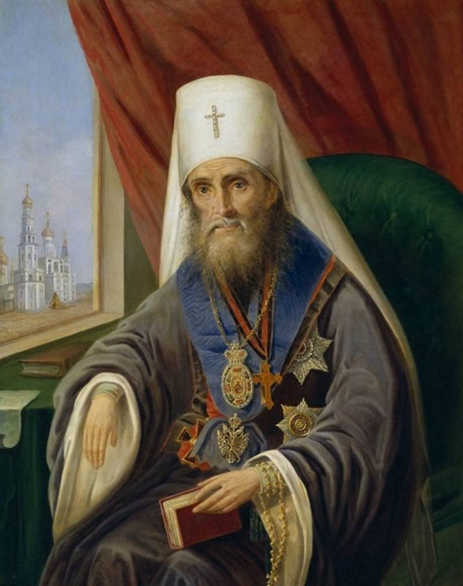O Lord, I do not know what to ask of Thee. Thou alone know what I need. Thou love me more than I know how to love myself. O Father, grant Thy servant what I myself do not know how to ask. I do not dare to ask a cross of Thee, nor consolation; I only stand before Thee with my heart open; Thou sees the needs that I myself do not know. Look, and work in me according to Thy mercy; smite and heal me, cast me down and raise me up! I am reverent and silent before Thy holy will and ways that are unfathomable to me. I offer myself as a sacrifice to Thee; teach me to pray. Do Thou Thyself pray in me. Amen.